Initializing Git if you cannot import projects

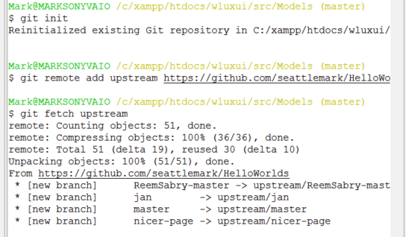

$git init

$ git remote add upstream <https://github.com/whoever/repo.git>

$ git fetch upstream

Then you should be able to import projects

Under File, choose Import then the following dialog box will appear:

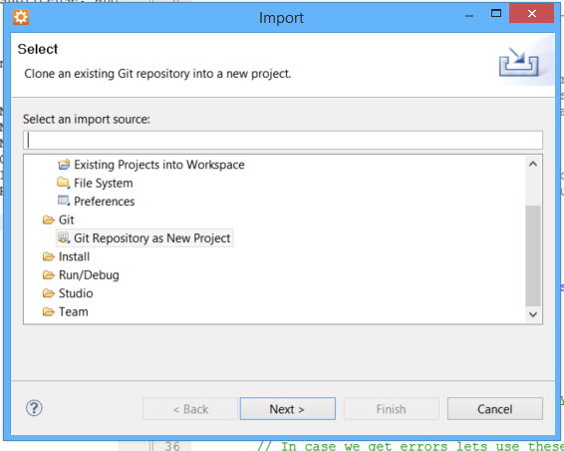

Choose Git then Git Repository as New Project

Make sure you have copied the git repo url from GitHub

